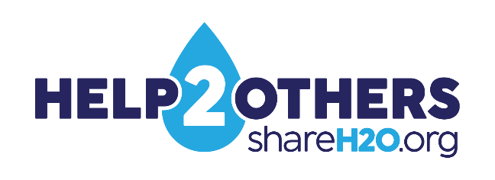
Hampton Roads Communities Unite to Support Neighbors in Need Through
Help 2 Others Water Assistance Program
Donors Invited to 'Adopt a Drop' and Make a Difference

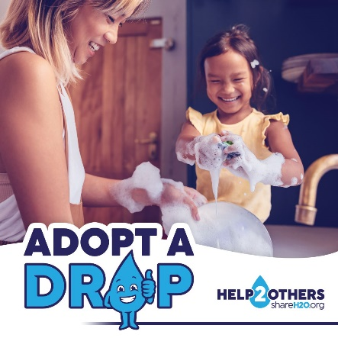
(Hampton Roads, Va., Dec. 2, 2024) – In Hampton Roads, many residents face the daunting reality of choosing between necessities like food, water and medical care. Unexpected challenges such as job loss or health issues can leave families struggling to pay their bills. The Hampton Roads Help 2 Others (H2O) water assistance program aims to ease this burden.
Administered by the Hampton Roads Planning District Commission and HRSD, in partnership with The Salvation Army, the program provides eligible residents with one-time financial assistance of up to $500 to cover their local water and wastewater utility bills. This year, program organizers invite residents and businesses to “adopt a drop” to help neighbors in need.
“Donating may seem like a drop in the bucket to some, but to families in crisis, it can mean the difference between having clean water or going without,” said H2O Program Manager Katie Cullipher. “Every contribution, big or small, directly supports our neighbors in need and strengthens our community.”

Help at a critical time
To be eligible, recipients of H2O funds must live in the service area of a participating Hampton Roads utility. Applicants must also show they have been affected by a personal or family crisis, such as a death, catastrophic illness, or sudden decrease in family income.”
Seth Atkinson knows firsthand how much the H2O program is needed in the region. As the social services program manager for The Salvation Army’s Hampton Roads Area Command, he manages the initial assessment of those applying for relief funds in his area.
“Nearly all of the people we serve are living paycheck to paycheck, and the smallest crisis makes them fall behind; a health emergency or a car that breaks down,” said Atkinson. “There’s hardly enough money to pay the day-to-day expenses, and then this massive bill arrives. That can be devastating.”
Residents can apply for H2O assistance by contacting their local Salvation Army command. Salvation Army representatives complete the initial assessment to verify eligibility and how much is owed. Then they submit a request to HRSD, which makes the payment on the customer’s behalf and ensures they stay connected to their water service.
“The H2O funds are managed by a trusted agency, based on the client’s need. It is a very safe way to give,” Atkinson said. “You are assured the money flows to the right place.”

How to donate
Residents can make a one-time or recurring donation to H2O through the Facebook page, PayPal, Venmo, credit card or by check. Hampton Roads Help 2 Others is a 501(c)(3) non-profit organization, making all program donations tax deductible. In addition, 100% of all contributions apply directly to the water or wastewater bill of someone in need in the local area.
For those involved in the program, H2O is not just about managing the program and administering the funds. In this season of giving, Cullipher and Atkinson hope that Hampton Roads residents and businesses will consider supporting this program that provides a life-giving resource to residents going through a difficult time.
“Consider what your support will mean to others,” Cullipher said. “When you 'adopt a drop,’ you provide access to hot showers, clean clothes and fresh water from the tap. We often take that for granted, but for a family experiencing financial hardship going without it is a reality. Join us in making a difference. Together, we can ensure that every resident in Hampton Roads has continued access to clean water.”
To donate or learn more about the Help 2 Others water assistance program, please visit shareh2o.org. Visual assets for media use are available at this link.

Media Contacts:
Katie Cullipher, Help to Others Program Manager, (757) 420-8300; kcullipher@hrpdcva.gov
Elizabeth Evans, Red Chalk Studios (757) 705-7153; elizabeth@redchalkstudios.com

About Help 2 Others (H2O) – The HRPDC and HRSD administer the H2O program in partnership with The Salvation Army. Families or individuals in danger of losing residential water service due to a crisis can receive one-time financial assistance of up to $500 to pay their water or wastewater bills. Participating cities and counties include Chesapeake, Franklin, Gloucester, Hampton, Isle of Wight, James City, Newport News, Norfolk, Poquoson, Portsmouth, Smithfield, Southampton, Suffolk, Surry, Virginia Beach, Williamsburg, Windsor and York. Visit shareh2o.org.

